Open Data Project for School

Attendance Matters & Assessment

Data Protection Impact Assessment

Submitting controller details
Name of controller | Eduboard Ltd (Company Number 10570208) t/a askEddi. ICO Registration ZA278740
Subject/title of DPO | 3rd party DPO service contracted by ASCL
Name of controller contact | Brendan Nel, CEO

Step 1: Identify the need for a DPIA
Explain broadly what project aims to achieve and what type of processing it involves. You may find it helpful to refer or link to other documents, such as a project proposal. Summarise why you identified the need for a DPIA.
Eduboard have partnered with the Association of Schools and College Leaders (ASCL) to deliver the Open Data Project for Schools to pioneer a new way of managing and reporting pupil attendance data along with a formative assessment framework.
The Attendance Matters product has been developed to provide a straightforward, highly effective attendance analysis system that works with schools existing Management Information System (MIS).
askEddi platform receives all data via Wonde Ltd who act as an integration layer between the schools and askEddi with the schools data stored in a cloud database for provision of data visualisation dashboards and functioning of the system.
The data transformation procedure in the data cloud creates a comprehensive list of reports and graphs which are utilised by schools.
Accessed by a web browser, Attendance Matters reduces workload and administration so schools have better quality information, and more time to act and deliver intervention when it really matters.
Only school email addresses can be used to access the secure system which relies on single sign-on authentication.

Step 2: Describe the processing
Describe the nature of the processing: how will you collect, use, store and delete data? What is the source of the data? Will you be sharing data with anyone? You might find it useful to refer to a flow diagram or other way of describing data flows. What types of processing identified as likely high risk are involved?
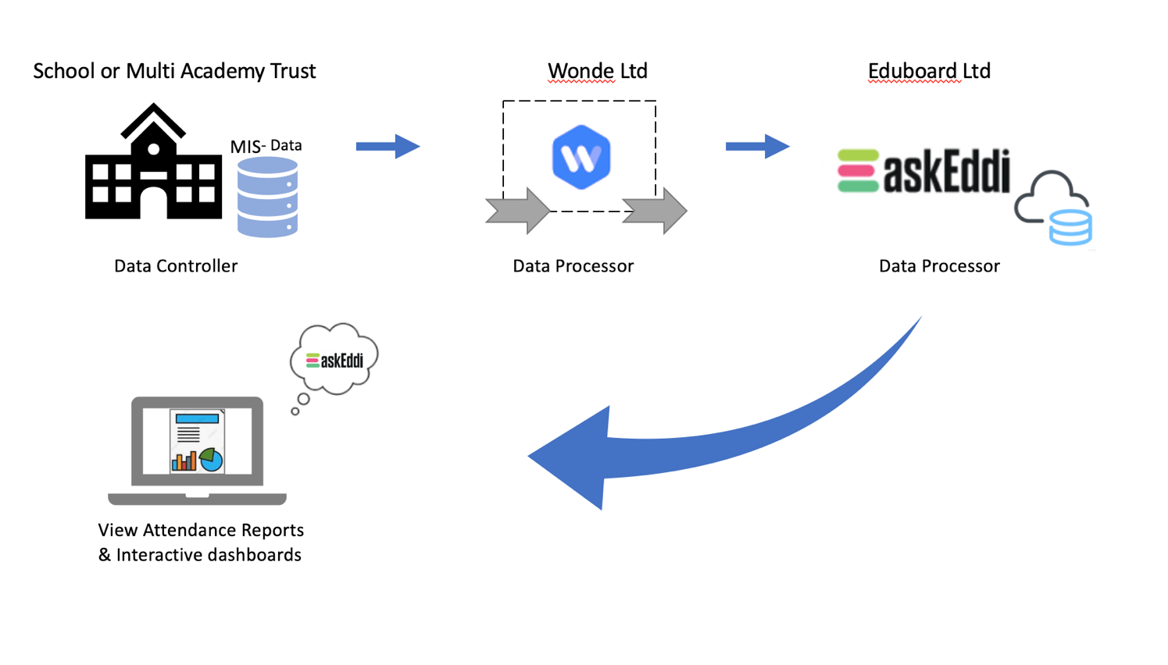
Attendance data is collected in a school MIS when registers are taken. This data is synced daily to the askEddi platform using Wonde integration tool. askEddi processes the data on behalf of the school to deliver a comprehensive suite of dashboards used across the whole school. These dashboards reduce the need for manual production of reports and analytics.

The school data is only provided back to the school for its own use and follows the guidelines set by the schools on GDPR and processing procedures.

An intervention module allows schools to also manage and track complex attendance issues and will store additional data related to attendance case management.

Note: Benchmark is a secondary product being produced in partnership with ASCL whereby schools will be able to share data with ASCL in an anonymized manner to allow for research and benchmarking between schools.
Describe the scope of the processing: what is the nature of the data, and does it include special category or criminal offence data? How much data will you be collecting and using? How often? How long will you keep it? How many individuals are affected? What geographical area does it cover?
The data consists mainly of attendance and assessment information, this includes student demographic information along with school related administration information to produce the data visualizations. This will include cohort analysis parameters associated to the students held in the schools MIS, i.e. SEND, FSM, LEA care.
All attendance data is collected daily to develop a comprehensive view of attendance over time which is held for the duration of the student’s attendance at the school. If the student continues to the school’s 6th form the attendance collection is continued or otherwise purged. Likewise in a primary school data is purged at the end of year 6.
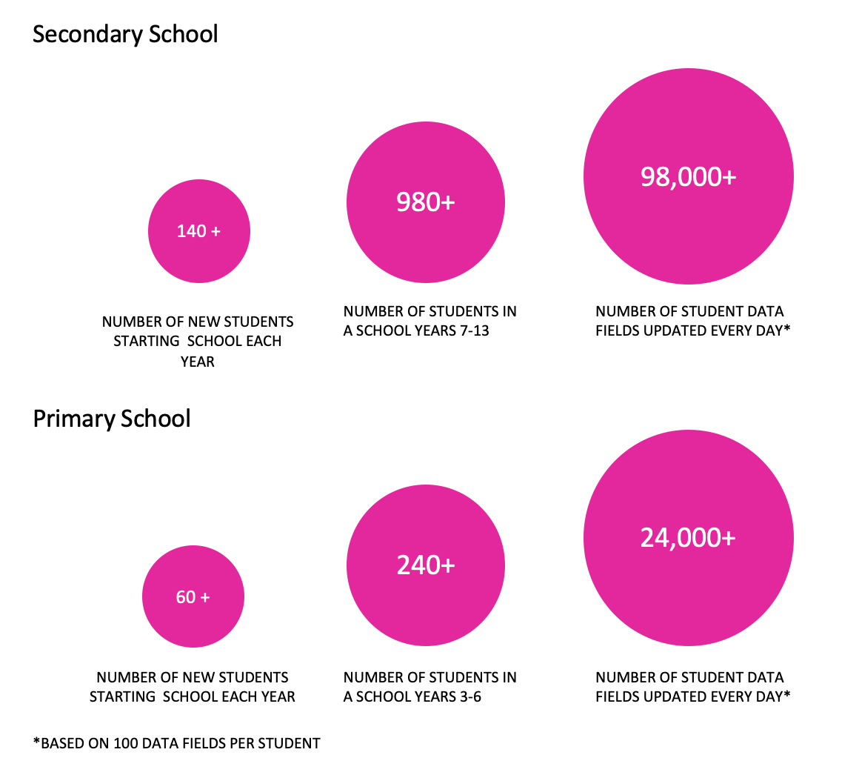

The data collected and processed can be categorized as follows:

Business Data | School Data
•Users’ names and contact information (including email addresses);  •Details of interactions that the School has with the Company regarding the Platform, together with any other information that the School and chooses to provide the Company with, for example, through correspondence and interactions with customer and technical support teams  •Information collected automatically relating to the Platform to include information eg a user’s IP address, device type, unique device identification numbers and login information, browser-type and version, time zone setting, operating system and platform, broad geographic location (e.g. country or city-level location) and other technical information;  •Information collected automatically relating to the Platform about how a User’s device has interacted with the Platform, including the pages accessed and links clicked, download errors, length of visits to certain pages, page interaction information, and methods used to browse away from any page. | - School name and contact information (including school postal address, phone number and email address),  - pupils’ first, middle and last names,  - gender  - Unique Pupil Number (UPN),  - dates of birth,  - class year groups,  - pupil attainment,  - attendance,  - Gifted & Talented status  - Additional cohort parameters contained in school MIS outlined in Special Category Data below
Details of Special Category Data
The School Data will comprise of Special Categories of personal data, namely the cohort parameters listed here:
Free School Meals*
Free School Meals 6*
In Local Authority Care*
Ever In Care*
English As Additional Language
Premium Pupil Indicator*
SEN
Ethnicity
Religion

*Whilst not expressly special category, these categories of data will be treated as special category.

Sharing these Cohort analysis indicators with the company via Wonde, will allow the company to provide the school with access to a full range of analysis tools. However, the school is able to restrict access to these Cohort analysis indicators via its Wonde account thus limiting the available analysis and functioning of the dashboards.

Describe the context of the processing: what is the nature of your relationship with the individuals? How much control will they have? Would they expect you to use their data in this way? Do they include children or other vulnerable groups? Are there prior concerns over this type of processing or security flaws? Is it novel in any way? What is the current state of technology in this area? Are there any current issues of public concern that you should factor in? Are you signed up to any approved code of conduct or certification scheme (once any have been approved)?
School Leaders, Attendance Managers and teachers access the Attendance Matters platform via their preferred web browser typically at the office or from home. The reports and interactive dashboards provide instant access to complex data sets reducing workload and creates great insight to a pupil attendance records. Only a valid school email can be used to access the system, the school maintains complete control of user access and permissions on the EDDI platform.

All data is collected from the schools MIS to ensure accuracy and contains reports on individual students, registrations groups and year groups. The platform provides detailed information on authorised and unauthorised absence marks including any late sessions.
Attendance Matters product enables users to filter results by registration, year groups and individual student attendance profiles over a term, academic year-to-date and specific date range on students’ characteristics such as pupil premium, free school meals or SEN status categories including attendance/absence reason codes.

From the point of entering a second-year subscription student data becomes comparable against current and past terms, helping schools identify concerning trends and patterns and then deliver appropriate interventions to address absence issues.
We are Cyber Essentials Certified

Describe the purposes of the processing: what do you want to achieve? What is the intended effect on individuals? What are the benefits of the processing – for you, and more broadly?
Better attendance at school by pupils improves their educational achievements. Even a small reduction in absence can result in pupils receiving greater benefit from their education.
Attendance Matters is the only fully developed system on the market to help with whole school wide attendance improvement and working practices, the alternative way is via manual tasks of extracting data and manipulating spreadsheets and reports to prepare the information required form teachers, heads of year, pastoral teams, EWO, senior leadership teams and governing bodies.
Information provided can be used to identify various cohorts including vulnerable students who are facing particular attendance challenges.
The efforts of the Department for Education, local authorities and schools are starting to have an impact. They must keep up the momentum and reinforce in schools and among parents & pupils the importance of attending school and the positive impact this can have on attainment and life opportunities.
Attendance Matters supports school improvement by reducing workload, creating accurate insight so more time can be spent on intervention instead of manual data processing and report generation.

Step 3: Consultation process
Consider how to consult with relevant stakeholders: describe when and how you will seek individuals’ views – or justify why it’s not appropriate to do so. Who else do you need to involve within your organisation? Do you need to ask your processors to assist? Do you plan to consult information security experts, or any other experts?
The project is a collaboration between the Association of School and College Leaders (ASCL), a pilot group of schools from different local authorities in North West England, School Leaders across the country and Eduboard, through the forum of the Open Data Project for Schools.
Duncan Baldwin, Deputy Director of Policy at the Association of School and College Leaders
Tiffnie Harris, Primary Specialist, The Association of School and College Leaders (ASCL)
Derbyshire County Council Children’s Services

Step 4: Assess necessity and proportionality
Describe compliance and proportionality measures, in particular: what is your lawful basis for processing? Does the processing actually achieve your purpose? Is there another way to achieve the same outcome? How will you prevent function creep? How will you ensure data quality and data minimisation? What information will you give individuals? How will you help to support their rights? What measures do you take to ensure processors comply? How do you safeguard any international transfers?
Delivered by ASCL, The Open Data Project and askEddi is a secure platform for schools to view and compare the data they already collect for the benefit of pupils. Please note school and pupil data is not shared with schools outside of a MAT.
Under the General Data Protection Regulation (GDPR), the lawful basis we generally rely on is Article 6(1)(b) for processing information. However, we feel it is helpful to set out the lawful bases that may be relied on by the schools that are sharing data with us. Schools should ensure that they have selected and documented the appropriate legal bases for their purposes:

Type of data | Shared by | Shared with | Lawful basis
Business data | School | The company | Article 6 (1) (b) Contract
School data | School | The company & Wonde | Article 6 (1) (e)  Public Task
School special category data | School | The company & Wonde | Article 9 (2) (g) Substantial public interest

The data shared is the minimum required to provide a straightforward, highly effective attendance analysis system that works with schools MIS.
Reports are created by selecting group or student categories providing authorised and authorised information. There are no specific fields to complete.

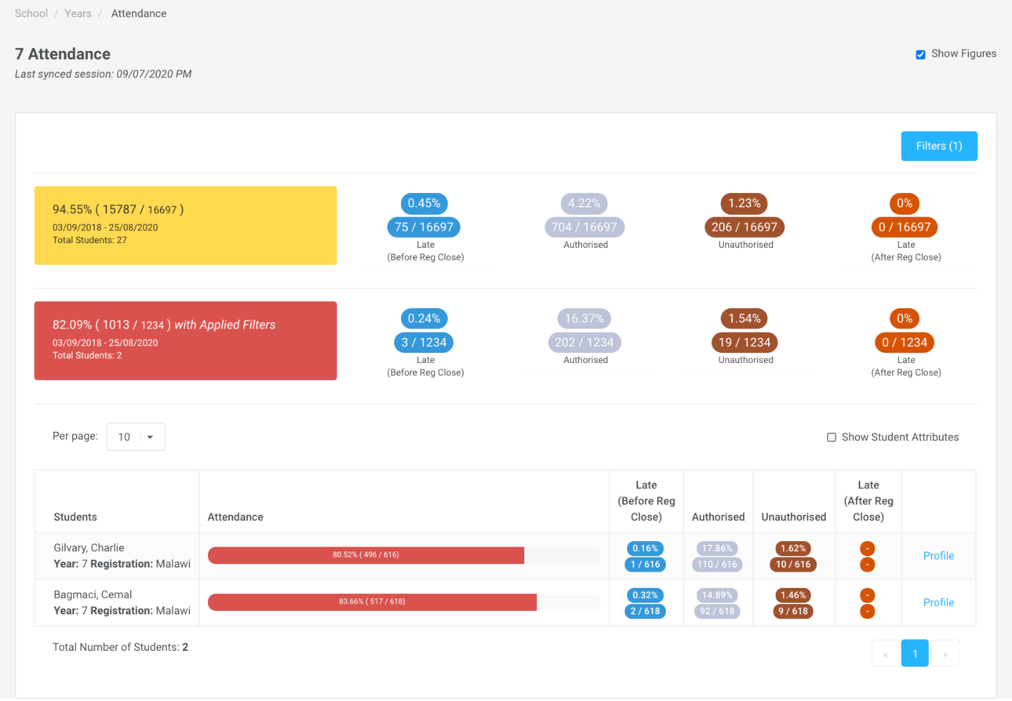

We are committed to providing all reasonable and timely assistance (including by appropriate technical and organisational measures) to the School to enable the School to respond to: any request from a Data Subject to exercise rights under Applicable Data Protection Law (including its rights of access, correction, objection, erasure and data portability, as applicable); and any other correspondence, enquiry or complaint received from a Data Subject, regulator or other third party in connection with the processing of the Data.

Step 5: Identify, assess risks and mitigate risks
Stage | Risk Description | Potential impact | Owner | Priority | Prospect | Severity | Risk Level | Control Measures to Minimise Risk | New Level
GDPR | Inaccurate data provisioned.  Risks would include non-compliance (data being accurate and up to date) as well as corporate risks (loss of credibility, risks of enforcement action, press coverage etc.) | Potential impact on individuals would include loss of confidentiality and potential embarrassment depending on nature of inaccurate data processed. | School | Immediate | 4 | 2 | M | Warning notice – The school takes full responsibility in the accuracy of the data provided in the upload stage. | L
 | Platform processing more personal data than is required for their purpose.  Risks would include non-compliance (data being adequate, relevant & limited) as well as corporate risks (loss of credibility, enforcement action being taken, press coverage etc.) | Potential impact on individuals would include loss of confidentiality, potential embarrassment and potential harm depending on the nature of the data processed. | Eduboard | Immediate | 3 | 2 | L | Processing is only performed under the school’s control of the data once extracted via Wonde, and subsequently viewed on a web-based platform.  At any point before, during or after can the school withdraw its data (including amending, deleting all or individual records) | L
 | Passing of personal data to third parties not being authorised by school to receive the data.  Risks would include non-compliance (data not used for specified, explicit & legitimate purpose) and corporate (loss of credibility, enforcement action being taken, press coverage, possible legal action for personal compensation etc.) | Potential impact on individuals would include loss of confidentiality, potential embarrassment and even harm depending on the nature of the data transferred incorrectly. | Eduboard | Immediate | 3 | 2 | L | Clearly defined in the Data Sharing agreement and T&C’s who the 3rd party platforms are we use for the platform and that the data will not be passed onto 3rd parties | L
 | School level data passed to third party for the wrong school through the platform  Risks would include non-compliance (failing to ensure appropriate security of the data) as well as corporate risks (loss of credibility, press coverage, enforcement action, personal compensation claims etc). | Impact on the individuals include their data being seen by staff from another school, loss of confidentiality, potential embarrassment depending on the nature of the exposed personal data. | Eduboard | Immediate | 3 | 3 | M | Schools remain controllers and will manage the accuracy of the data they input to the system.  The data scheme is secure and will prevent data from being passed to the wrong school. | L
 | School staff email unprotected personal data to the platform  This can occur when there is a need for support whereby school staff see issues with the data and email the personal data to support staff for investigation.  Risks include non-compliance (failing to ensure appropriate security of the data) along with corporate risks (loss of credibility, press coverage, enforcement action, personal compensation claims etc). | Impact on individuals include their data being seen by integrator staff, the dangers inherent in emails being sent to incorrect recipients, loss of confidentiality, possible embarrassment or harm depending on the nature of the exposed data and its final recipient. | Eduboard | Immediate | 3 | 3 | M | Our support protocol will be to support the school requiring receipt of a valid staff email address, Eduboard do not require password information as this remains in control of the school. All support will make sure no additional data is requested. | L

Step 6: Sign off and record outcomes
Item | Name/position/date | Notes
Measures approved by: | Brendan Nel | Integrate actions back into project plan, with date and responsibility for completion
Residual risks approved by: | Brendan Nel | If accepting any residual high risk, consult the ICO before going ahead
DPO advice provided: | Clare Wilson  Education Data Hub DPO service 9th September 2020 | DPO should advise on compliance, step 6 measures and whether processing can proceed
Summary of DPO advice:
- Given that the cohort analysis parameters associated to the students held in the schools MIS are likely to include Special Category Data, or data that should be treated as such eg FSM; the list provided should be exhaustive rather than indicative – can you confirm this is the case? I would expect ethnicity, EAL, G&T, PP as well. A table showing the data sets extracted and whether they are compulsory or optional would greatly assist here.
DPO advice accepted or overruled by: | Brendan Nel | If overruled, you must explain your reasons
Comments:
Accepted and implemented herein, in the DSA and PN
Consultation responses reviewed by: |  | If your decision departs from individuals’ views, you must explain your reasons
Comments:
This DPIA will kept under review by: | Brendan Nel | The DPO should also review ongoing compliance with DPIA

