SixIntoSeven DPIA

Submitting controller details
Name of controller | Eduboard Ltd (Company Number 10570208) t/a askEddi. ICO Registration ZA278740
Subject/title of DPO | 3rd party DPO service contracted by ASCL
Name of controller contact | Brendon Nel, CEO Eduboard

Step 1: Identify the need for a DPIA
Explain broadly what project aims to achieve and what type of processing it involves. You may find it helpful to refer or link to other documents, such as a project proposal. Summarise why you identified the need for a DPIA.
The parties are participating in a project which is a rapid response to Covid-19 enabling a professional judgement of a pupil’s capability in certain subjects and skill areas in their final year of primary school, to be shared with a secondary school the pupil will attend. This allows the secondary school to prepare for the start of the new academic year, support curriculum design and identify learning needs of the year 7 cohort without the need for immediate testing to form a baseline. Eduboard provide the SixIntoSeven platform on the OpenDataProject Website to deliver an alternative means of assessing the pupils. https://opendataproject.org.uk/sixintoseven/
Through a matching process in the system, a requesting Secondary school’s pupil identifier made up of UPN or DOB and names will be used. This will identify a corresponding record provided by a Primary school and provide the data in the Secondary schools’ dashboard. This dashboard will download to a csv file for school use.

Step 2: Describe the processing
Describe the nature of the processing: how will you collect, use, store and delete data? What is the source of the data? Will you be sharing data with anyone? You might find it useful to refer to a flow diagram or other way of describing data flows. What types of processing identified as likely high risk are involved?
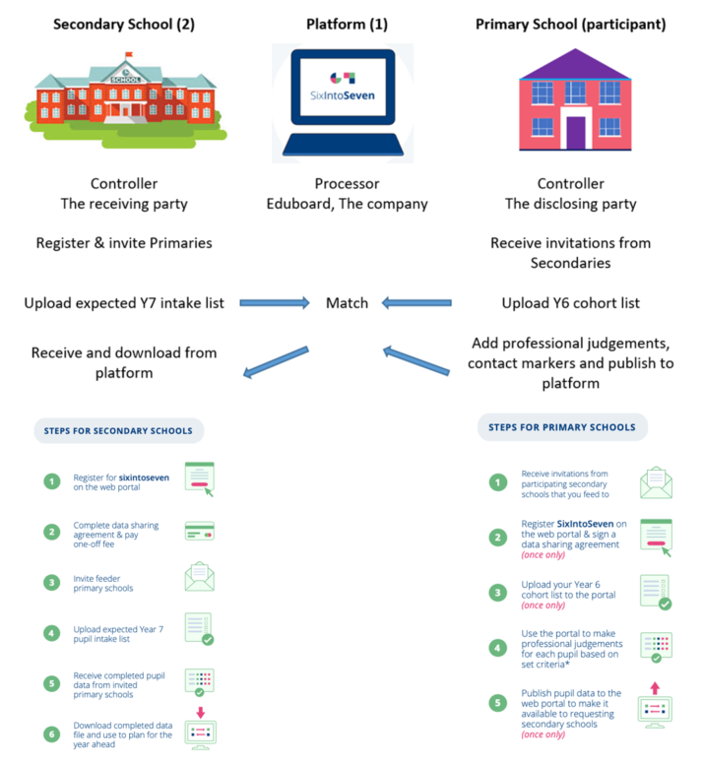

Describe the scope of the processing: what is the nature of the data, and does it include special category or criminal offence data? How much data will you be collecting and using? How often? How long will you keep it? How many individuals are affected? What geographical area does it cover?
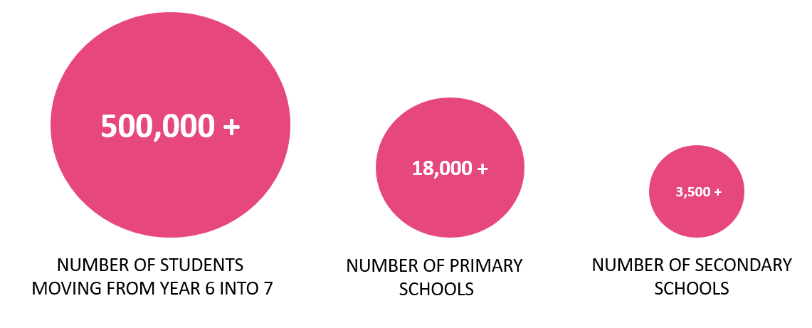

The project will be, after a consultation and trial period, available nationally, to any subscribing secondary school, along with its partner / feeder primaries.
The data collected and processed can be categorized as follows:
Business Data | School Data
•Users’ names and contact information (including email addresses);  •Details of interactions that the School has with the Company regarding the Product, together with any other information that the School and chooses to provide the Company with, for example, through correspondence and interactions with our customer and technical support teams  •Information collected automatically relating to the Product to include information eg a user’s IP address, device type, unique device identification numbers and login information, browser-type and version, time zone setting, operating system and platform, broad geographic location (e.g. country or city-level location) and other technical information;  •Information collected automatically relating to the Product about how a User’s device has interacted with the Site, including the pages accessed and links clicked, download errors, length of visits to certain pages, page interaction information, and methods used to browse away from any page. | •School name and contact information (including school postal address, phone number and email address),  •pupils’ first, middle and last names,  Unique Pupil Number (UPN), dates of birth, class year groups, professional judgement of pupil attainment, ‘contact required’ marker.
No school data will be retained by us beyond 31st July 2021.

Describe the context of the processing: what is the nature of your relationship with the individuals? How much control will they have? Would they expect you to use their data in this way? Do they include children or other vulnerable groups? Are there prior concerns over this type of processing or security flaws? Is it novel in any way? What is the current state of technology in this area? Are there any current issues of public concern that you should factor in? Are you signed up to any approved code of conduct or certification scheme (once any have been approved)?
In the normal course of events, Secondary Schools would receive Standard Assessment Test (SATs) results for their new y7 intake. The Covid19 outbreak has seen the cancellation of all external examination series and so the current y6 cohort have not undertaken SATs. As a consequence the Secondary schools will have an intake who not only have suffered from an unprecedented disruption in schooling, but also without the foundation of performance data to allow them to plan, support and meet the needs of this extraordinary cohort.
We have built a platform to facilitate primary teachers’ professional judgement to be shared with their secondary colleagues to enable the appropriate planning and support to be available for this cohort on entry into Y7.
We are confident that parents expect there to be communication between schools in order to facilitate a seamless transition into secondary education, now more than ever.

We are Cyber Essentials Certified

Describe the purposes of the processing: what do you want to achieve? What is the intended effect on individuals? What are the benefits of the processing – for you, and more broadly?
Secondary schools usually plan their Year 7 curriculum using information gained from the Year 6 SATs. As these were not taken this year, SixIntoSeven provides an opportunity for information on pupil progress to flow between the feeder primary school and the destination secondary school.
SixIntoSeven fills the gaps left by school closures and disruption to normal procedures around transition such as SATs results and assessments. Primary school teachers input professional judgements on each pupil to show their progress in key curriculum areas. Secondary school teachers use this information to understand the capabilities of each pupil to target the most appropriate learning.
SixIntoSeven ensures that secondary schools can easily decide which pupils need additional support and which elements of the curriculum have not been covered by each pupil.

Step 3: Consultation process
Consider how to consult with relevant stakeholders: describe when and how you will seek individuals’ views – or justify why it’s not appropriate to do so. Who else do you need to involve within your organisation? Do you need to ask your processors to assist? Do you plan to consult information security experts, or any other experts?
The project is a collaboration between the Association of School and College Leaders (ASCL), a pilot group of schools from different local authorities in North West England, School Leaders across the country and askEddi, through the forum of the Open Data Project for Schools.
Duncan Baldwin, Deputy Director of Policy at the Association of School and College Leaders
Tiffnie Harris, Primary Specialist, The Association of School and College Leaders (ASCL)
Red Kite Learning Trust
Derbyshire County Council Children’s Services

Step 4: Assess necessity and proportionality
Describe compliance and proportionality measures, in particular: what is your lawful basis for processing? Does the processing actually achieve your purpose? Is there another way to achieve the same outcome? How will you prevent function creep? How will you ensure data quality and data minimisation? What information will you give individuals? How will you help to support their rights? What measures do you take to ensure processors comply? How do you safeguard any international transfers?
Delivered by ASCL, The Open Data Project is a secure platform for schools to share and compare the data they already collect for the benefit of pupils.
Under the General Data Protection Regulation (GDPR), the lawful basis we generally rely on is Article 6(1)(b) for processing information. However, we feel it is helpful to set out the lawful bases that may be relied on by the schools that are sharing data with us. Schools should ensure that they have selected and documented the appropriate legal bases for their purposes. Data subjects should ascertain the school’s legal bases from the schools.
Type of data | Shared by | Shared with | Lawful basis
Business data | Secondary | The company | Article 6 (1)(b) Contract
 | Primary | The company | Article 6 (1)(b) Contract
School data | Secondary | The company | Article 6 (1)(e) Public Task
 | The company | Secondary | Article 6 (1)(b) Contract
 | Primary | The company | Article 6 (1)(e) Public Task
 | Primary | Secondary | Article 6 (1)(e) Public Task
The data shared is the minimum required to carry out successful matching between schools. Then follows the Professional Judgment as outlined below. Alternatives would be for this to be carried out directly between schools without the need for a third party ‘intermediary’. However, given the enormity of the pressures faced by schools during the pandemic, this provides a secure, efficient and consistent method, devised by school leaders.
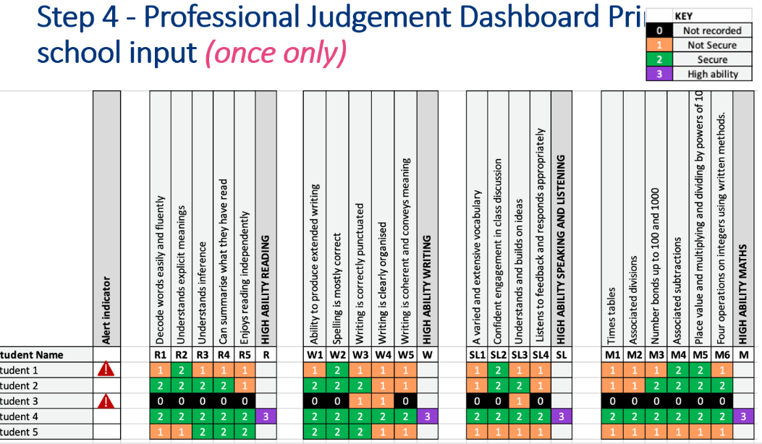

There are specific fields to complete, when uploading data onto the platform, and this is done manually not by using an MIS data extraction tool. So only the minimum required data is shared.
The following advice is issued to schools around data quality:

“You can alter any saved work. Once the data has been published it cannot be amended. If it is a minor mistake, we would ask you to contact the school directly. If it is a major problem, such as the UPNs are not matched up correctly to the names, please contact support.”

The following is included in the T&Cs in relation to Data Subjects’ rights:
The Company shall provide all reasonable and timely assistance (including by appropriate technical and organisational measures) to the School to enable the School to respond to:
any request from a Data Subject to exercise rights under Applicable Data Protection Law (including its rights of access, correction, objection, erasure and data portability, as applicable); and
any other correspondence, enquiry or complaint received from a Data Subject, regulator or other third party in connection with the processing of the Data.

The following is included in the T&Cs in relation to International Transfers:
The Company shall not transfer the Data (nor permit the Data to be transferred) outside of the European Economic Area ("EEA") unless it first takes such measures as are necessary to ensure any such transfer is in compliance with Applicable Data Protection Law.

Step 5: Identify, assess risks and mitigate risks
Stage | Risk Description | Potential impact | Owner | Priority | Prospect | Severity | Risk Level | Control Measures to Minimise Risk | New Level
GDPR | Inaccurate data provisioned.  Risks would include non-compliance (data being accurate and up to date) as well as corporate risks (loss of credibility, risks of enforcement action, press coverage etc.) | Potential impact on individuals would include loss of confidentiality and potential embarrassment depending on nature of inaccurate data processed. | School | Immediate | 4 | 2 | M | Warning notice – The school takes full responsibility in the accuracy of the data provided in the upload stage. | L
 | Platform processing more personal data than is required for their purpose.  Risks would include non-compliance (data being adequate, relevant & limited) as well as corporate risks (loss of credibility, enforcement action being taken, press coverage etc.) | Potential impact on individuals would include loss of confidentiality, potential embarrassment and potential harm depending on the nature of the data processed. | Eduboard | Immediate | 3 | 2 | L | Processing is only performed on the primary schools control of the data through the publish stage.  At any point before, during or after can the primary school withdraw its data (including amending, deleting records all or individual) | L
 | Passing of personal data to third parties not being authorised by school to receive the data.  Risks would include non-compliance (data not used for specified, explicit & legitimate purpose) and corporate (loss of credibility, enforcement action being taken, press coverage, possible legal action for personal compensation etc.) | Potential impact on individuals would include loss of confidentiality, potential embarrassment and even harm depending on the nature of the data transferred incorrectly. | Eduboard | Immediate | 3 | 2 | L | Clearly defined in the Data Sharing agreement and T&C’s who the 3rd party platforms are we use for the platform and that the data will not be passed onto 3rd parties | L
 | School level data passed to third party for the wrong school trough the platform  Risks would include non-compliance (failing to ensure appropriate security of the data) as well as corporate risks (loss of credibility, press coverage, enforcement action, personal compensation claims etc). | Impact on the individuals include their data being seen by staff from another school, loss of confidentiality, potential embarrassment depending on the nature of the exposed personal data. | Eduboard | Immediate | 3 | 3 | M | Schools remain controllers and will manage the accuracy of the data they input to the system.  Use of UPN where available to match provides a 100% accuracy in the matching process as it is a unique number.  Where a secondary does not provide a UPN for matching we will mitigate this by only limiting the data to the requesting primary school and that the secondary school will have a validation process if a student with the exact same first, middle, last names including birthday is found in the primary school data being requested. In this situation the Secondary will have to contact to primary to validate the records being presented before academic data is presented. | L
 | School staff email unprotected personal data to the platform  This can occur when there is a need for support whereby school staff see issues with the data and email the personal data to support staff for investigation.  Risks include non-compliance (failing to ensure appropriate security of the data) along with corporate risks (loss of credibility, press coverage, enforcement action, personal compensation claims etc). | Impact on individuals include their data being seen by integrator staff, the dangers inherent in emails being sent to incorrect recipients, loss of confidentiality, possible embarrassment or harm depending on the nature of the exposed data and its final recipient. | Eduboard | Immediate | 3 | 3 | M | Our support protocol will be to support the school without needing to receive the data. All support will make sure no data is requested. The format of the data is the most import part to the upload stage. | L
 | Matching failure caused by password changes resulting in out of date personal data within third-party solutions  password updates may be actioned by the school/platform | Risks to the individual potential embarrassment and possibly harm depending on the nature of the out of date personal data being used by the third-party solutions.  Risks include non-compliance (failing to ensure data is accurate and up to date, failure to ensure appropriate security of the data) plus corporate risk (loss of credibility, press coverage, enforcement action, personal compensation claims etc). | Eduboard | Immediate | 2 | 1 | L | System is password protected and only users from the registered school can be invited to the system. | L

Step 7: Sign off and record outcomes
Item | Name/position/date | Notes
Measures approved by: |  | Integrate actions back into project plan, with date and responsibility for completion
Residual risks approved by: |  | If accepting any residual high risk, consult the ICO before going ahead
DPO advice provided: |  | DPO should advise on compliance, step 6 measures and whether processing can proceed
Summary of DPO advice:
DPO advice accepted or overruled by: |  | If overruled, you must explain your reasons
Comments:
Consultation responses reviewed by: |  | If your decision departs from individuals’ views, you must explain your reasons
Comments:
This DPIA will kept under review by: |  | The DPO should also review ongoing compliance with DPIA

